KABARAK  UNIVERSITY

DEPARTMENT OF COMPUTER SCIENCE AND IT

LAND REGISTRY SYSTEM USING BLOCKCHAIN TECHNOLOGY

By:
EMMANUEL LELEI
INTE/MG/1626/09/22

A project/Proposal submitted in partial fulfillment for the requirement of the award of Information Technology Degree of Kabarak University.

JULY, 2025

DECLARATION

STUDENT:
I declare that this project is my original work and has not been submitted to any other institution of higher learning for academic credit.

NAME: EMMANUEL LELEI REG. NO: INTE/MG/1626/09/22

Signature …………………………………… Date ……………………………………...

SUPERVISOR:
This project has been submitted with my approval as the University Supervisor:

NAME: EVANS CHESANG

Signature …………………………………… Date ……………………………………...

DEDICATION

This project is dedicated to my family, whose unwavering and steadfast encouragement has been a consistent source of strength throughout my academic journey. It is also dedicated to all property owners, prospective land investors, and the dedicated legal professionals within the land sector. Our aim is for this work to significantly contribute to fostering enhanced transparency, security, and efficiency in the critical area of property record management. Ultimately, this comprehensive effort serves the broader community, aspiring to cultivate robust, trust-enhancing digital solutions that genuinely address real-world challenges and promote collective well-being in Africa.

ACKNOWLEDGEMENT
I begin by expressing profound gratitude to the Almighty God for the sustained strength, health, and perseverance granted throughout the conception and completion of this academic work.
My deepest appreciation is extended to my supervisor, Mr. Evans Chesang, for his invaluable professional guidance, insightful feedback, and steadfast support during every phase of this research. His expertise was crucial to this project's development.
Special acknowledgment is also given to the esteemed lecturers and the entire faculty of the Department of Computer Science & IT at Kabarak University. Their comprehensive knowledge and dedicated mentorship have significantly contributed to my academic and professional growth.
Furthermore, I am sincerely grateful to my family and friends for their consistent encouragement, patience, and motivation, which proved invaluable during demanding periods.
Finally, this project was deeply inspired by the challenges faced by property owners, prospective land investors, and legal professionals in existing land administration processes. This work is dedicated to developing practical, secure, and transparent solutions that aim to bring meaningful improvement to their interactions within the land sector.

TABLE OF CONTENTS

Table of Contents
DECLARATION 2
DEDICATION 3
ACKNOWLEDGEMENT 4
TABLE OF CONTENTS 5
List of figures 8
ABSTRACT 9
CHAPTER ONE 10
INTRODUCTION 10
1.1 Introduction 10
1.2 Background of the Study 10
1.3 Problem Statement 11
1.4 Objectives of the Study 12
1.4.1 General Objective 12
1.4.2 Specific Objectives 12
1.5 Research Questions 13
1.6 Significance of the Study 13
1.7 Scope and limitations of the Study 14
1.8 Proposed Modules 15
CHAPTER TWO 17
LITERATURE REVIEW 17
2.1 Introduction 17
2.2 Traditional Land Registry Systems 17
2.3 The Role and Limitations of Centralized Authorities and Intermediaries 18
2.4 Digital Transformation in Land Administration 19
2.5 Existing Digital and Blockchain-Based Land Registry Initiatives 20
2.5.1 Digital Land Registry Systems 20
2.5.2 Blockchain-Based Land Registry Pilot Projects 21
2.6 Key Technologies in Blockchain-Based Land Registry Systems 22
2.7 Gaps in Current Systems 23
2.8 Rationale for a Blockchain-Based Land Registry System 24
2.9 Conceptual Framework and Diagram 24
2.9 Summary 25
CHAPTER THREE: 26
RESEARCH METHODOLOGY 26
3.1 Introduction 26
3.2 Research Design 26
3.3 Data Collection Methods 27
3.3.1 Primary Data 27
3.3.2 Secondary Data 27
3.4 Development Methodology 28
3.5 System Analysis 28
3.5.1 Functional Requirements 28
3.5.2 Non-Functional Requirements 29
3.6 System Design 30
3.7 Research Ethics 34
3.8 Summary 34
CHAPTER FOUR: 35
SYSTEM IMPLEMENTATION AND DEPLOYMENT 35
4.1 Introduction 35
4.2 Environmental Setup 35
4.2.1 Software Tools and Technology 35
4.2.2 Environment Configuration 36
4.3 Implementation Setup 36
4.3.1 System Modules and Functionality 36
4.3.2 Coding Standards and Best Practices 37
4.3.3 User Interface and Screenshots 37
4.4 Testing and Quality Assurance 40
4.4.1 Testing Strategies 40
4.4.2 Results 40
4.4.3 Evaluation Metrics 41
4.4.4 Issue tracking and Quality Assurance 41
4.5 Deployment Plan 42
4.6 Go-live Plan 42
4.7 Maintenance and Support 42
4.8 Conclusion and Future work 43
4.8.1 Conclusion 43
4.8.2 Future Work 43
REFERENCES 44

List of figures
Figure 1 conceptual diagram 25
Figure 2 System Architecture Diagram 30
Figure 3 ERD Diagram 31
Figure 4 use case diagram 32
Figure 5 dfd diagram 33
Figure 6:Landing page 37
Figure 7: Dashboard 38
Figure 8: Land Registry Form 38
Figure 9: Listed Properties 39
Figure 10:Admin Dashboard 39

LIST OF ABBREVIATIONS
API – Application Programming Interface​
CI – Continuous Integration​
DApp – Decentralized Application​
DB – Database​
DFD – Data Flow Diagram​
DLT – Distributed Ledger Technology​
ERD – Entity–Relationship Diagram​
ETH – Ether (Ethereum Native Cryptocurrency)​
GIS – Geographic Information System​
GUI – Graphical User Interface​
HTTP – Hypertext Transfer Protocol​
IDE – Integrated Development Environment​
IPFS – InterPlanetary File System​
JSON – JavaScript Object Notation​​
NFT – Non-Fungible Token (if mentioned)​
QA – Quality Assurance​
REST – Representational State Transfer​
SDLC – Software Development Life Cycle​
TCP/IP – Transmission Control Protocol / Internet Protocol​
UAT – User Acceptance Testing​
UML – Unified Modeling Language​
URL – Uniform Resource Locator​
UX – User Experience​

​​

ABSTRACT

Recognizing land as an inherently precious and foundational commodity, this project critically examines and addresses the pervasive challenges of security, transparency, and operational efficiency that persistently affect conventional land registration systems. The overarching aim was to establish a robust and innovative digital framework capable of significantly mitigating instances of fraudulent activities, substantially streamlining complex property transfer processes, and providing an inherently immutable and verifiable record of land ownership. These efforts collectively seek to foster a much higher degree of public trust and confidence within the land administration sector. The methodology employed involved the meticulous design and subsequent implementation of a decentralized application (DApp), strategically built upon the resilient Ethereum blockchain. This architecture leverages sophisticated smart contracts to automate and secure the intricate procedures involved in land registration and subsequent transfer operations. A carefully defined, controlled access mechanism, overseen by a designated superadmin (representing a government authority), was integrated specifically for the initial registration of properties, thereby ensuring data integrity and authenticity at the critical point of entry, while simultaneously preserving transactional transparency between all involved parties. Key findings from this development indicate that the constructed system successfully demonstrates the practical feasibility of conducting direct, cryptographically verifiable, and tamper-proof property transactions. This approach notably reduces the traditional reliance on multiple intermediaries, which often introduce inefficiencies and vulnerabilities. Ultimately, this comprehensive blockchain-powered solution presents a highly scalable and reliable alternative, unequivocally underscoring the transformative potential of distributed ledger technology in modernizing and securing global land administration practices.

Keywords: Blockchain, Decentralized Application, Ethereum, Land Administration, Land Registry, Smart Contracts, Transparency

CHAPTER ONE

INTRODUCTION

1.1 Introduction
This chapter provides the foundational context for the proposed blockchain-based land registry system. It begins by outlining the current state of land administration, emphasizing land's economic importance and the challenges inherent in traditional record-keeping. The section then precisely defines the specific issues this project addresses, such as fraud and inefficiencies in land transactions. Subsequently, the project's objectives and the innovative blockchain solutions are presented. Key system modules and their functionalities are introduced to offer an initial understanding of the operational structure. The significance of this research, its defined scope, and any inherent limitations are also discussed, establishing clear boundaries. This chapter thus articulates the rationale for the project, preparing the reader for the detailed exploration in subsequent sections.

1.2 Background of the Study
Land stands as a fundamental asset, serving as a cornerstone for economic development, social stability, and individual prosperity globally. Effective land administration is therefore paramount for any nation. Traditionally, land registration and management systems, particularly in many developing economies, have predominantly relied on manual, paper-based processes and centralized record-keeping. These conventional approaches typically involve extensive physical documentation, including title deeds, survey maps, and transaction records, which are meticulously maintained in government registries. While these systems aimed to provide legal certainty and facilitate property transactions, their inherent design has introduced a myriad of challenges over time.
These traditional frameworks are often characterized by significant operational inefficiencies, leading to prolonged transaction periods and substantial administrative burdens. The reliance on physical documents makes them highly susceptible to loss, damage, and unauthorized alterations, undermining the integrity of land records. Furthermore, the centralized nature of these systems can foster an environment conducive to corruption, including the proliferation of fraudulent activities such as the issuance of counterfeit titles and the illicit double-selling of properties. Transparency is frequently compromised, making it difficult for stakeholders to independently verify ownership details or transaction histories. This opacity often results in a lack of public trust and contributes to numerous land-related disputes and litigations. Consequently, the limitations of conventional land registry systems underscore a pressing need for innovative solutions that can deliver enhanced security, verifiable transparency, and improved efficiency in land administration.

1.3 Problem Statement

Despite the critical importance of land as a fundamental asset, existing conventional land registration and management systems are plagued by significant deficiencies that undermine their effectiveness and reliability. These systems are predominantly characterized by cumbersome manual processes, centralized data storage, and reliance on physical documentation, rendering them highly susceptible to operational inefficiencies, prolonged transaction cycles, and administrative bottlenecks. More critically, their inherent vulnerabilities to fraud, data manipulation, and corruption—including instances of forged titles and illicit double-selling of properties—erode public confidence and lead to extensive land-related disputes. The lack of transparent and easily verifiable transaction histories further exacerbates these issues, making it challenging for stakeholders to ascertain genuine ownership and secure their investments. Consequently, the current state of land administration often results in a climate of mistrust, substantial financial losses for individuals and institutions, and impediments to economic development. There is a compelling need for a modern, secure, and transparent framework that can overcome these systemic flaws and restore integrity to land ownership records.

1.4 Objectives of the Study

1.4.1 General Objective

The general objective of this study is to design and develop a secure, transparent, and efficient land registry system utilizing blockchain technology to address the prevailing challenges within traditional land administration frameworks.

1.4.2 Specific Objectives

The specific objectives of this study are:
- To analyze the existing challenges and vulnerabilities in traditional land registration systems.
- To design a blockchain-based architecture for a decentralized land registry system that ensures immutability and transparency.
- To develop a prototype of a land registry decentralized application (DApp) on the Ethereum blockchain, incorporating smart contracts for secure property transfers.
- To evaluate the developed system's effectiveness in enhancing security, efficiency, and transparency in land transactions, and in mitigating fraudulent activities.

1.5 Research Questions
This study seeks to answer the following research questions:
- What are the key challenges and vulnerabilities inherent in current traditional land registration systems?
- How can a blockchain-based architecture be designed to ensure immutability and transparency in a decentralized land registry system?
- How can a prototype of a land registry decentralized application (DApp) be developed on the Ethereum blockchain to facilitate secure property transfers using smart contracts?
- How effective is the developed blockchain-based land registry system in enhancing security, improving efficiency, increasing transparency in land transactions, and mitigating fraudulent activities?

1.6 Significance of the Study
This study holds significant implications for various stakeholders within the land administration ecosystem. Primarily, the development of a blockchain-based land registry system offers enhanced security and integrity for property records, substantially reducing the risks of fraud, tampering, and illicit transactions that plague traditional systems. This increased reliability will instill greater confidence and trust among property owners, prospective buyers, and investors, encouraging more secure and transparent land dealings.
For landowners and buyers, the system promises a streamlined, more efficient, and less cumbersome process for property registration and transfer, minimizing delays and associated costs. Legal professionals involved in conveyancing will benefit from a more verifiable and accessible transaction history, simplifying due diligence. Furthermore, government agencies responsible for land administration can achieve greater operational efficiency, reduce administrative burdens, and enhance their capacity to maintain accurate and immutable records.
Beyond direct users, this project contributes to broader socio-economic development by fostering a more stable and trustworthy land market, which can attract both local and foreign investment. It serves as a practical demonstration of how emerging technologies like blockchain can address critical real-world problems in public administration, potentially inspiring further innovation in other sectors. Ultimately, by promoting transparency and accountability, this study aims to contribute to a more equitable and secure land tenure system for communities.

1.7 Scope and limitations of the Study
The primary focus of this project is the comprehensive design, development, and rigorous testing of a blockchain-based land registry decentralized application (DApp). The system is engineered to serve several key user groups:
- Property Owners: Who will be able to securely register their land details and initiate ownership transfers.
- Prospective Buyers: Who can verify land authenticity, ownership history, and securely acquire property.
- Government Registrars/Superadmins: Tasked with initial land registration, system oversight, and ensuring data integrity.
- Legal Professionals: Who will utilize the system for due diligence and verifying transaction validity.
The platform's core functionalities will include immutable record-keeping, cryptographic security for transactions, automated smart contract execution for transfers, and a transparent audit trail of all land-related activities. While the current implementation focuses on a foundational DApp, future enhancements could involve integration with existing cadastral mapping systems for spatial data, and broader legal framework compliance for national rollout.

Limitations of the Study
This study acknowledges several inherent limitations:
- The prototype's evaluation is conducted within a simulated environment, which may not fully replicate the complexities and extensive transaction volumes of a large-scale national land registry.
- The rapidly evolving legal and regulatory landscape surrounding blockchain technology in land administration is not comprehensively addressed, as the study primarily focuses on technical feasibility.
- The initial reliance on a centralized superadmin for data entry, while practical for controlled system introduction, presents a degree of centralization that diverges from a purely decentralized blockchain model.
- The project does not encompass the intricate process of migrating existing historical land records from traditional systems onto the blockchain.
- Potential challenges related to widespread user adoption, particularly among individuals less familiar with digital platforms, are acknowledged but not fully explored within this study.

1.8 Proposed Modules
The blockchain-based land registry system is architected into distinct modules, each responsible for specific functionalities within the decentralized application (DApp). These modules collectively ensure the transparency, security, and efficiency of land registration and property transactions on the Ethereum blockchain:
- Admin and Registration Module:
- This module manages the initial entry of land details. It includes functionalities to addSuperAdmin(), allowing the contract owner to register government authorities and assign them to specific villages. The Registration() function then enables these authorized superadmins to input new land parcel information, such as state, district, village, survey number, owner address, and market value, with a unique property ID generated for each record.
- Property Information and Search Module:
- This module facilitates access to land data. It includes computeId() for generating unique property identifiers. Users can retrieve land details through landInfoOwner() (for owners to see comprehensive data including request status) and landInfoUser() (for general users to view public property information). Additionally, viewAssets() allows individuals to see their owned properties.
- Transaction Management Module:
- This module orchestrates the secure transfer of land ownership. It features makeAvailbale() for owners to list their property for sale, and requestToLandOwner() for buyers to initiate a purchase. The seller can then viewRequest() and processRequest() (accept or reject). Upon approval, buyProperty() handles the secure transfer of funds and ownership, with removeOwnership() updating the previous owner's records.
These modules, powered by Ethereum smart contracts, demonstrate a streamlined and secure approach to land administration, enhancing transparency and mitigating traditional vulnerabilities in property transactions.

CHAPTER TWO

LITERATURE REVIEW

2.1 Introduction

This chapter provides a comprehensive review of literature on land registration systems and blockchain technology. It establishes a theoretical foundation by exploring traditional land administration, identifying its strengths and weaknesses. The review then delves into blockchain's core principles and its applications in various sectors. Finally, it critically examines existing blockchain-based land registry initiatives, highlighting knowledge gaps and underscoring this study's unique contributions to land administration.

2.2 Traditional Land Registry Systems
Traditional land registry systems form the bedrock of property ownership and transfer across most global jurisdictions. These systems are typically centralized, government-managed, and heavily reliant on manual, paper-based record-keeping. They involve physical documents such as title deeds, cadastral maps, and transaction records, stored in central offices (Swan 2015).
While providing a historical framework for property rights, these conventional systems are increasingly challenged by modern demands. Key inefficiencies arise from manual record-keeping, leading to administrative overheads and slow processing. Their centralized nature creates a single point of failure, making them highly vulnerable to corruption, data manipulation, and fraudulent activities like forged documents and double-selling (Lemieux, 2017).
Furthermore, the inherent lack of real-time accessibility and transparency in many traditional systems hinders efficient due diligence. This opacity erodes public trust and frequently leads to protracted legal disputes. These systemic vulnerabilities collectively underscore a critical need for more robust and technologically advanced solutions in land administration (World Bank, 2019).

2.3 The Role and Limitations of Centralized Authorities and Intermediaries
In traditional land registry systems, centralized authorities and various intermediaries play pivotal roles in facilitating property transactions and maintaining records. Government land departments act as the central custodians of ownership information, while professionals such as lawyers, real estate agents, and surveyors often serve as essential middlemen, guiding parties through complex legal and administrative processes. While their involvement is intended to ensure legality and order, it frequently introduces significant limitations:
- Increased Costs: The necessity of engaging multiple intermediaries, each charging fees for their services (e.g., legal fees, search fees, agency commissions), substantially inflates the overall cost of land transactions.
- Information Asymmetry: Centralized systems can create information silos, where complete and real-time data regarding property history, encumbrances, or transaction status is not readily transparent or accessible to all parties, leading to potential exploitation.
- Bureaucratic Delays: The multi-step processes involving numerous approvals and manual verification by centralized authorities and intermediaries often result in prolonged transaction timelines, administrative bottlenecks, and frustrating delays.
- Vulnerability to Corruption and Fraud: Centralized control points and the discretionary power of some intermediaries can create opportunities for corrupt practices, including bribery, document manipulation, and the facilitation of fraudulent transfers, eroding public trust.
- Lack of Direct Accountability: The fragmented nature of interactions across multiple intermediaries can obscure clear lines of accountability when errors or malpractices occur, making recourse difficult for affected parties.
These inherent issues within centralized structures and the reliance on numerous intermediaries contribute significantly to the inefficiencies, high costs, and security vulnerabilities that plague conventional land administration, thereby necessitating more direct and transparent engagement models (World Bank, 2019).

2.4 Digital Transformation in Land Administration
Globally, the land administration sector is undergoing a significant digital transformation, driven by the imperative to overcome the inefficiencies and vulnerabilities of traditional paper-based and manual systems. This shift involves leveraging various technologies to enhance the coordination, visibility, and trustworthiness of land records and transactions. Many countries are investing in computerized land information systems and online platforms to streamline processes, improve accessibility, and provide more accurate data.
Digital platforms offer several distinct advantages over conventional methods:
- Enhanced Accessibility and Convenience: Online portals and digital databases enable stakeholders to conduct land searches, submit applications, and track transaction statuses remotely, reducing the need for physical visits to registry offices.
- Improved Efficiency and Speed: Automation of routine tasks, digital document processing, and electronic record-keeping significantly reduce transaction times and administrative bottlenecks.
- Greater Transparency and Data Integrity: Digitization can provide a clearer audit trail of changes to records and reduce opportunities for manual manipulation, although it still relies on the security of centralized servers.
- Reduced Operational Costs: Streamlined digital workflows and reduced reliance on extensive paper archives can lead to long-term cost savings for government agencies and, potentially, for users.
- Better Data Management and Analysis: Digital records facilitate easier data storage, retrieval, and analysis, supporting better urban planning, land use management, and policy formulation.
While digital transformation marks a crucial step forward, many initial digital systems are still centralized and may inherit some vulnerabilities of their manual predecessors, particularly concerning data security and resistance to tampering. This sets the stage for more advanced, decentralized solutions like blockchain

2.5 Existing Digital and Blockchain-Based Land Registry Initiatives
The global drive towards modernizing land administration has led to various digital and, more recently, blockchain-based initiatives. These efforts aim to overcome the limitations of traditional systems by leveraging technology to enhance efficiency, transparency, and security.
2.5.1 Digital Land Registry Systems
Many countries have embarked on digitizing their land records, moving from paper-based archives to electronic databases. A notable example is Estonia's Digital Land Register (KRIS), operational since 2005. This system allows electronic saving, storing, and reproduction of land register information, facilitating electronic conveyancing and real-time data exchange with other government registers (e.g., land cadastre, business register) via its X-Road system. Similarly, Mauritius successfully transitioned to a paperless Registrar General Department through its eRegistry Project, significantly improving its "Ease of Doing Business" ranking by enabling online searches, document submission, and fee payments.
While these digital systems offer substantial improvements in accessibility and efficiency, they often remain centralized. This centralization, as seen in some implementations, can still present vulnerabilities such as:
- Single Point of Failure: Centralized servers can be targets for cyber-attacks or system failures.
- Data Integrity Concerns: Although digital, the potential for unauthorized internal manipulation or errors during data entry and updates can persist if robust controls are not in place.
- Trust Dependence: Users still rely heavily on the central authority for the integrity and accuracy of the digital records.
- Data Migration Challenges: The process of digitizing historical paper records is often complex, time-consuming, and prone to errors, potentially transferring inaccuracies into the new digital system. Kenya's Ardhi Sasa platform, for instance, has faced challenges.

2.5.2 Blockchain-Based Land Registry Pilot Projects
Building upon the lessons from traditional digitization, several countries and organizations have explored blockchain technology for land registries, aiming for higher levels of immutability and trustlessness. These initiatives typically leverage blockchain's distributed ledger capabilities and smart contracts:
- Georgia (Bitfury Partnership): In 2016, Georgia partnered with Bitfury to pilot a blockchain-based land titling system. This project primarily implemented a blockchain-based timestamping layer on top of the existing digital land registry, hashing and timestamping land certificates on the Bitcoin blockchain. This added an immutable audit trail, enhancing the integrity and verifiability of records without completely overhauling the front-end user experience.
- Sweden (ChromaWay): Sweden's Lantmäteriet (Cadastral Authority) has conducted pilot projects with ChromaWay, exploring a full digital process for property transactions, including smart contracts for agreement and payment, and blockchain for recording ownership. Their focus has been on streamlining the entire conveyancing process, reducing manual steps and reliance on intermediaries.
- Honduras: A project in Honduras aimed to create a more transparent land registry using blockchain to address historical land disputes and corruption, focusing on establishing reliable ownership records for communities.
- Dubai: Dubai's government has expressed strong interest in using blockchain for various government services, including land registration. Their initiatives aim to streamline land transactions and enhance security for property records.
These pilot projects demonstrate the technical feasibility and potential benefits of blockchain in land administration, particularly in enhancing security through immutability and transparency. However, they also highlight challenges such as regulatory acceptance, the need for legal frameworks to recognize blockchain-based titles, scalability for national adoption, and the complexities of integrating with existing legal and administrative paradigms (Deshpande & Metri, 2018; Lemieux, 2017; World Bank, 2019).

2.6 Key Technologies in Blockchain-Based Land Registry Systems
The proposed decentralized land registry system leverages several advanced technologies to ensure security, transparency, and efficiency:
- Distributed Ledger Technology (DLT): Forms the core, providing a decentralized, replicated database across multiple network participants. This eliminates single points of failure and enhances resilience.
- Cryptography and Hashing: Essential for security. Cryptographic hashing (e.g., SHA256) creates immutable, tamper-proof records by linking blocks. Digital signatures authenticate transactions, ensuring data integrity and non-repudiation in property transfers.
- Smart Contracts: Self-executing agreements coded on the blockchain. They automate ownership transfers, enforce conditional logic (e.g., payment verification), and automatically update land records, significantly reducing delays and human error.
- Blockchain Platforms (e.g., Ethereum): Provide the underlying infrastructure for DApp development and smart contract deployment. Ethereum's robust environment supports complex transaction logic for intricate land processes.
- Decentralized Applications (DApps): Offer the user interface for interacting with the blockchain. DApps enable users and superadmins to perform functions like land registration, search, and transfer requests in a user-friendly manner.
These technologies collectively enable a land registry system that is inherently more secure, transparent, and efficient than traditional methods.

2.7 Gaps in Current Systems
Despite ongoing efforts in digital transformation, several critical gaps persist within both traditional and partially digitized land administration systems, which the proposed blockchain-based solution aims to address:
- Persistent Fraud and Tampering Vulnerabilities: While digitization reduces some physical risks, centralized digital databases remain susceptible to hacking, insider manipulation, and the creation of fraudulent records if not secured by decentralized cryptographic principles. The issue of forged title deeds and illicit double-selling of properties continues to be a major concern in many jurisdictions.
- Lack of True Transparency and Trustlessness: Existing systems often lack a fully transparent and publicly verifiable audit trail. Stakeholders must still place significant trust in a central authority or multiple intermediaries, which can be compromised, leading to a lack of confidence in the integrity of land records.
- Inefficiency and Bureaucratic Bottlenecks: Even with digital platforms, the multi-layered approval processes, manual verification steps, and coordination across various departments can still lead to significant delays and high transaction costs. The full automation of property transfer, from agreement to title update, is rarely achieved.
- Limited Accessibility and Data Silos: While some digital systems offer online access, comprehensive, real-time, and easily verifiable land information for all stakeholders (beyond basic search) is often fragmented or restricted. This creates data silos that hinder efficient due diligence and decision-making.
- Challenges in Cross-Jurisdictional Transactions: The lack of a standardized, universally verifiable system makes cross-border land transactions complex, costly, and prone to disputes due to differing legal frameworks and record-keeping standards.
- Difficulty in Historical Data Migration and Cleansing: The transition to new systems often grapples with the immense challenge of accurately migrating vast amounts of historical, often messy or incomplete, paper-based records, potentially perpetuating existing inaccuracies.

2.8 Rationale for a Blockchain-Based Land Registry System
The persistent issues of fraud, inefficiency, lack of transparency, and eroded trust in traditional land administration necessitate a robust solution. A blockchain-based land registry system offers a transformative approach to these systemic flaws.
This proposed system is designed to address these gaps by:
- Ensuring Immutability and Fraud Prevention: Cryptographic hashing and a distributed ledger make every record tamper-proof, drastically reducing forged titles and double-selling.
- Enhancing Transparency and Trust: All validated transactions are recorded on a verifiable blockchain, fostering a trustless environment where confidence rests in the technology.
- Streamlining Efficiency and Reducing Costs: Smart contracts automate property transfers, minimizing intermediaries, delays, and transaction costs.
- Improving Accessibility and Data Integrity: A decentralized network ensures high availability of consistent, accurate land information, aiding due diligence.
- Providing a Robust and Resilient Infrastructure: Blockchain's distributed nature eliminates single points of failure, increasing resilience against cyber-attacks or corruption.
Unlike centralized digital platforms, this blockchain-based solution offers a fundamentally secure, transparent, and efficient framework for land administration, paving the way for a more reliable land tenure system.

2.9 Conceptual Framework and Diagram
To visually synthesize the core arguments and relationships presented in this literature review, a conceptual framework has been developed. This diagram illustrates the interplay between traditional land registry challenges, the enabling power of blockchain technology, the proposed blockchain-based land registry system, and its anticipated benefits, ultimately contributing to enhanced public trust and economic growth.
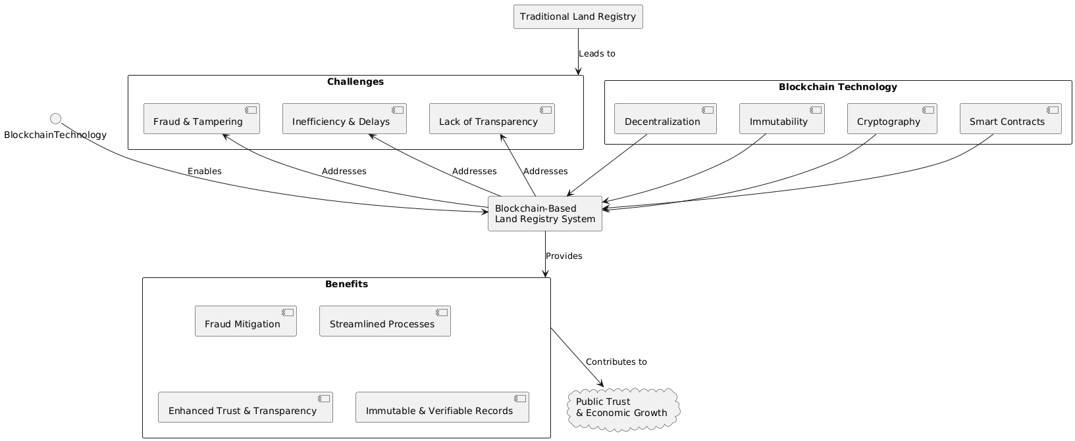
Figure 1 conceptual diagram

2.9 Summary

This chapter comprehensively reviewed literature on land administration and blockchain technology. It detailed the limitations of traditional, centralized land registries, emphasizing their susceptibility to fraud, inefficiency, and lack of transparency. Blockchain's foundational principles—decentralization, immutability, cryptography, and smart contracts—were explored for secure, automated data management. Existing digital and pilot blockchain initiatives were analyzed, noting advancements but also persistent centralized vulnerabilities. The review highlighted how blockchain directly addresses these shortcomings, identifying critical research gaps in comprehensive solutions, scalability, and integration, thus positioning this study to contribute significantly to a robust, integrated blockchain-based land registry system.

CHAPTER THREE:

RESEARCH METHODOLOGY

3.1 Introduction

This chapter outlines the research methodology employed in the design, development, and evaluation of the blockchain-based land registry system. It details the research approach, design, and the specific methods used for data collection, system development, and validation. The aim is to provide a clear and systematic account of the procedures followed to achieve the study's objectives and answer the research questions. This methodology ensures the rigor and reproducibility of the research findings, demonstrating how the theoretical concepts discussed in the literature review were translated into a practical and verifiable solution.

3.2 Research Design
The study follows a Design Science Research Methodology (DSRM), which is highly suitable for problem-solving and technological innovation. DSRM focuses on building artifacts that provide practical utility. The process adopted for this project included the following key phases:
- Problem Identification: Clearly defining the challenges and vulnerabilities inherent in traditional land registry systems.
- Objective Definition: Establishing precise objectives for the proposed blockchain-based solution.
- Design & Development: The iterative process of designing and building the decentralized land registry system (DApp) and its underlying smart contracts.
- Demonstration & Evaluation: Presenting the developed artifact and rigorously assessing its effectiveness in addressing the identified problems and meeting the defined objectives.

3.3 Data Collection Methods

3.3.1 Primary Data
Primary data was collected directly from relevant stakeholders to gather firsthand insights into current challenges and evaluate the developed prototype:
- Questionnaires: During the user testing and evaluation phases of the developed DApp, questionnaires were administered to capture quantitative and qualitative feedback on system usability, user satisfaction, perceived security, and the overall effectiveness of the blockchain solution.
- Observation: Direct observation of user interaction with the prototype DApp was conducted during testing sessions to identify usability issues, workflow bottlenecks, and areas for improvement in real-time.

3.3.2 Secondary Data
Secondary data was gathered from existing sources to build a comprehensive understanding of the problem domain and relevant technological solutions:
- Literature Review: Extensive review of academic papers, research journals, and industry reports on traditional land administration systems, blockchain technology fundamentals, smart contracts, and their applications in land registries. This informed the theoretical framework and problem identification.
- Case Studies: Analysis of existing digital land registry initiatives and blockchain-based pilot projects (e.g., those in Georgia, Sweden, Dubai) provided insights into successful implementations, common challenges, and best practices in the field. This helped to benchmark the proposed solution and identify research gaps

3.4 Development Methodology

The platform was developed using the Agile Software Development Life Cycle (SDLC), broken into iterative sprints. Agile was chosen because of its flexibility, user-centric design, and fast feedback loops.
Agile Phases Implemented:
- Requirements Analysis
- Sprint Planning
- Module Design
- Implementation
- Integration & Testing
- Deployment
- User Evaluation

3.5 System Analysis

3.5.1 Functional Requirements
These requirements specify the core functionalities and services that the system will provide to its users:
- User registration and login
- Profile creation for property owners/superadmins
- Property listings and filters
- Request and transaction management
- Blockchain-based payment integration
- Rating and feedback system
- Admin moderation dashboard

3.5.2 Non-Functional Requirements
These requirements define the quality attributes and constraints under which the system must operate:
- Web responsiveness and mobile compatibility
- High uptime and scalability
- Secure financial and user data handling
- Immutable record tracking
- Efficient query and transaction handling

3.6 System Design

(i) System Architecture/ Context Diagram
Refer to the system design diagram below.

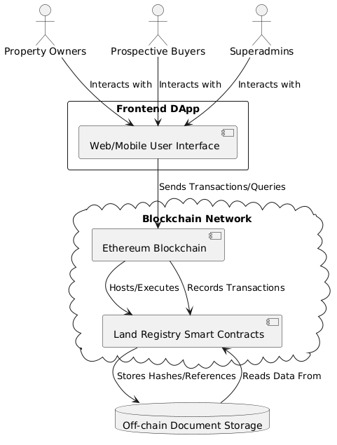
Figure 2 System Architecture Diagram

(ii)Entity-Relationship Diagram (ERD)
Refer to the ERD below.

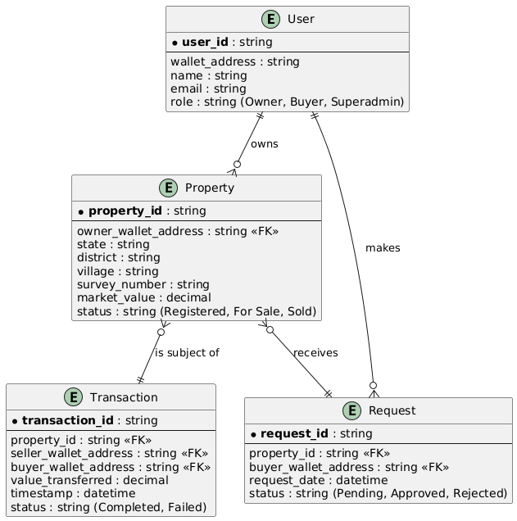
Figure 3 ERD Diagram

(iii)Use Case Diagram

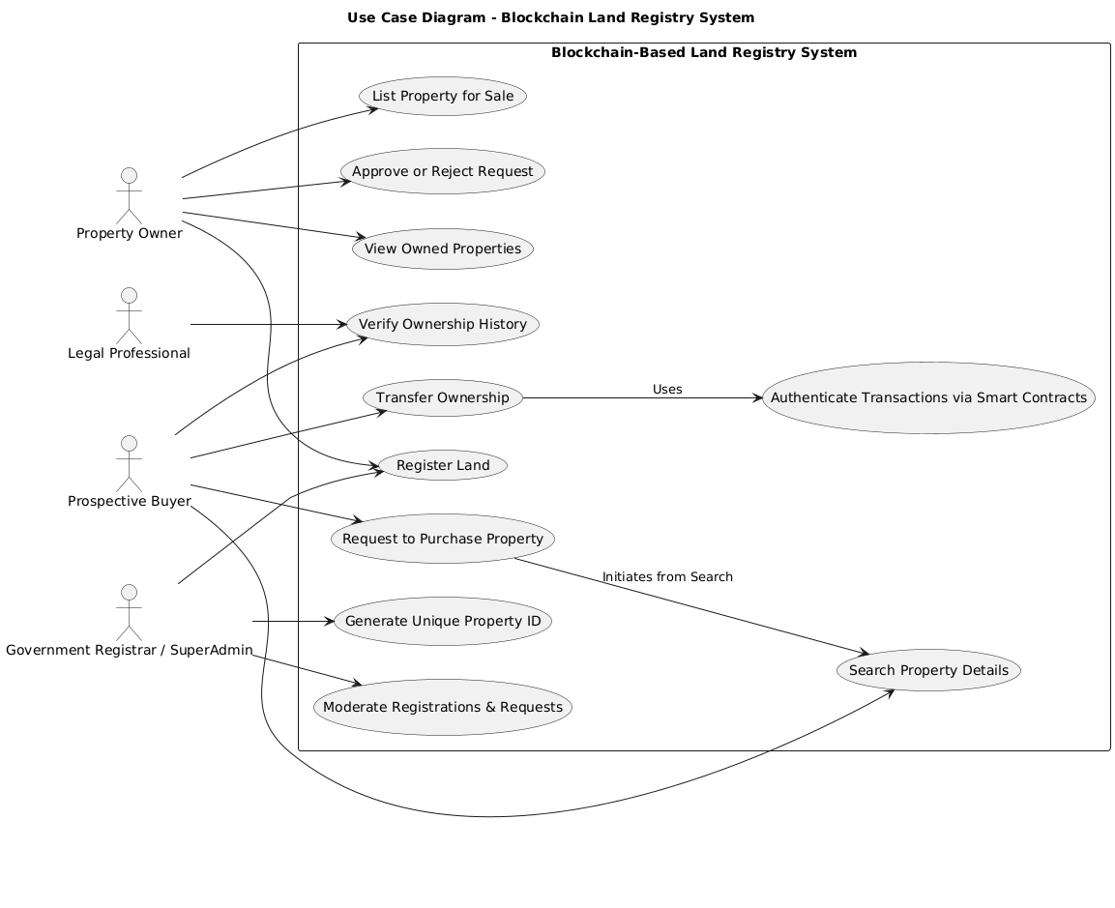
Figure 4 use case diagram

(iv)Data Flow Diagram
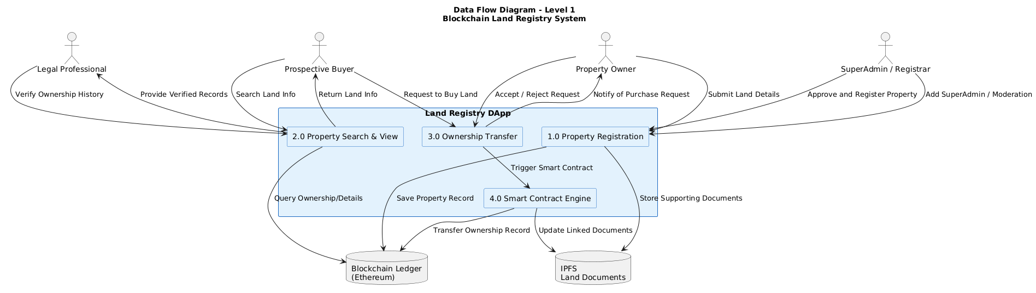
Figure 5 dfd diagram

Tools and Technologies Used

Component Technology
Blockchain Platform Ethereum (for smart contracts)
Smart Contract Language Solidity
Frontend React.js
Blockchain Interaction Web3.js / Ethers.js
Decentralized Storage IPFS
Version Control Git / GitHub

3.7 Research Ethics
Ethical principles guided all phases of this research, prioritizing participant protection and data integrity.
- i. Informed Consent: Participants were fully informed and provided voluntary consent for data collection and system testing.
- ii. Confidentiality and Anonymity: Personal identifiers were not collected or shared; data was anonymized to protect privacy.
- iii. Data Security and Privacy: Robust security measures, including HTTPS, protected all data, leveraging blockchain's cryptographic security for transactions.
- iv. Transparency and Open-Source Compliance: All utilized third-party components were properly licensed and acknowledged, ensuring research transparency.

3.8 Summary

This chapter has provided a detailed account of the methodology employed in developing the blockchain-based land registry system. It outlined the adoption of a Design Science Research Methodology, ensuring a problem-solving and innovation-focused approach. The chapter detailed the systematic data collection methods, encompassing both primary (interviews, questionnaires, observation) and secondary (literature, technical documentation, case studies) sources, which informed the system's requirements. Furthermore, it described the Agile Software Development Life Cycle utilized for iterative design, development, and testing, emphasizing flexibility and user-centricity. The functional and non-functional requirements were clearly defined, forming the blueprint for the system's architecture and design. Finally, the chapter highlighted the rigorous system testing and evaluation strategies, along with the ethical considerations that guided the entire research process. This comprehensive methodology ensures that the developed blockchain-based land registry system is not only technically sound but also effectively addresses the identified challenges in traditional land administration, offering a robust and verifiable solution.

CHAPTER FOUR:

SYSTEM IMPLEMENTATION AND DEPLOYMENT

4.1 Introduction

This chapter presents the complete implementation and deployment process of the Land Registry System using Blockchain Technology. It details the setup of the development environment, how different modules and components were built, the testing and quality assurance strategies adopted, deployment procedures, go-live preparations, maintenance and user support plans, as well as concluding insights and pointers for future work. The approaches and outcomes discussed here provide evidence of the practical realization of the proposed system.

4.2 Environmental Setup

4.2.1 Software Tools and Technology

The following tools and platforms were selected based on their alignment with project requirements and current industry standards:
- Blockchain Platform: Ethereum
- Smart Contract Language: Solidity
- Frontend Framework: React.js
- Backend: Node.js
- Blockchain Integration: Web3.js/Ethers.js libraries
- Containerization & Deployment: Docker, Ganache (for local blockchain testing)
- Version Control: Git and GitHub
- Development Environment: Visual Studio Code (VSCode) IDE
- Testing Frameworks: Truffle for smart contracts

4.2.2 Environment Configuration

- Installed Node.js and npm to manage dependencies.
- Set up Ganache for a local Ethereum test blockchain.
- Configured Truffle for compiling, migrating, and testing Solidity contracts.
- Initialized a React.js frontend using create-react-app.
- Created a GitHub repository for source code management and version control.
- Used Docker to encapsulate and deploy key services in isolated environments.
- Integrated Web3.js for frontend DApp↔blockchain interactions.

4.3 Implementation Setup

4.3.1 System Modules and Functionality

The solution follows a modular architecture, each serving a specific domain:
a) Admin & Registration Module
- Only a government “superadmin” can register new land parcels and assign registrar roles.
- Each land record includes: state, district, village, unique property ID, owner address, and market value.
- Solidity function registerLand() encapsulates this logic.
b) Property Information and Search Module
- Enables users to search and view land information.
- Functions like landInfoOwner() and landInfoUser() provide comprehensive and filtered views.
- computeId() ensures unique property IDs.
c) Transaction Management Module
- Facilitates listing properties for sale, requesting transfers, processing approvals and finalizing secure ownership transfer via smart contracts.
- Workflow includes: makeAvailable(), requestToLandOwner(), processRequest(), buyProperty(), and removeOwnership().

4.3.2 Coding Standards and Best Practices

- Adopted clear naming conventions and modular code structure.
- Used in-line comments for maintainability.
- Followed “fail-safe” principles for blockchain state changes.
- Used .env files for sensitive environment variables.

4.3.3 User Interface and Screenshots

- Developed a clean, user-friendly React.js interface for both registrar/admin and public user interaction.
- Key sections implemented:
  - Dashboard (with user role-based access)
  - Registration form
  - Property search results page
  - Transaction activity log page

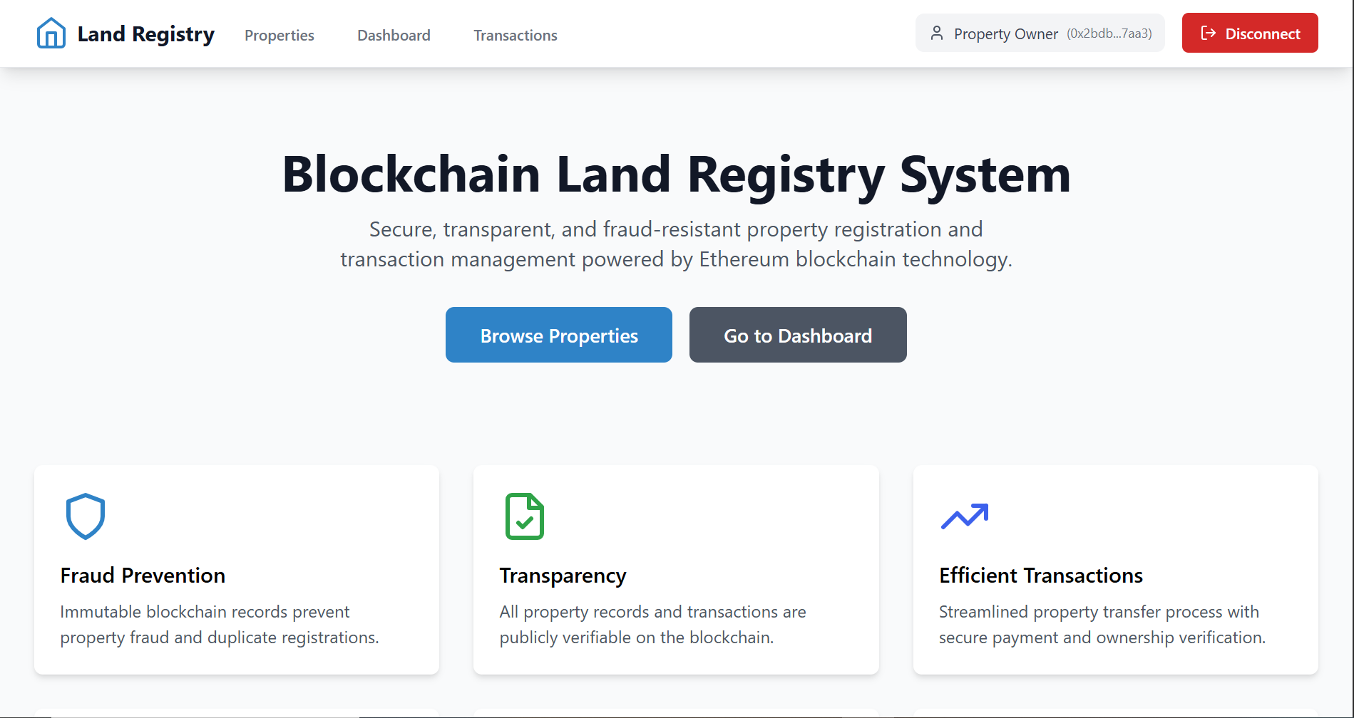
Figure 6:Landing page

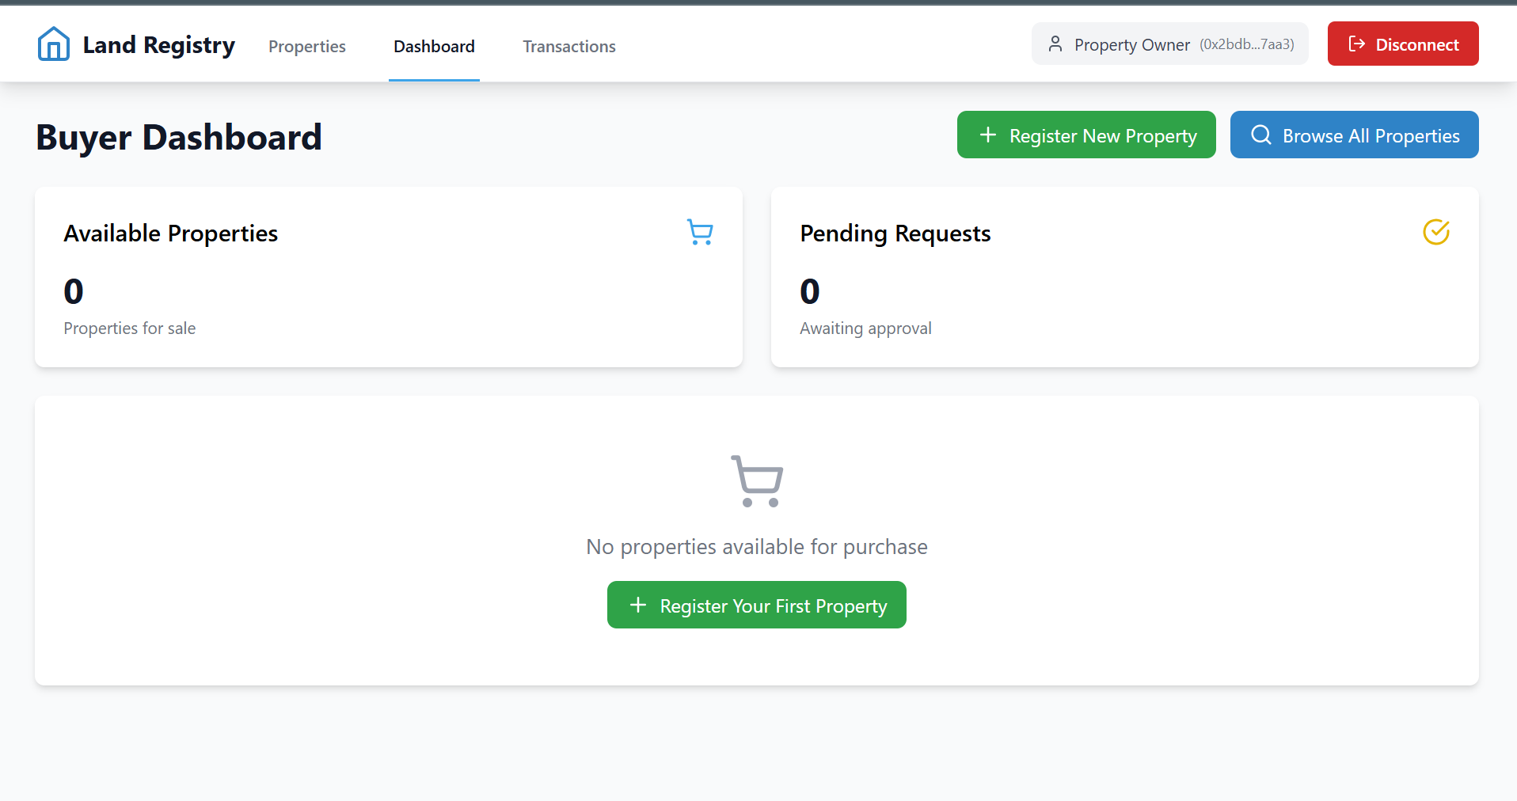
Figure 7: Dashboard

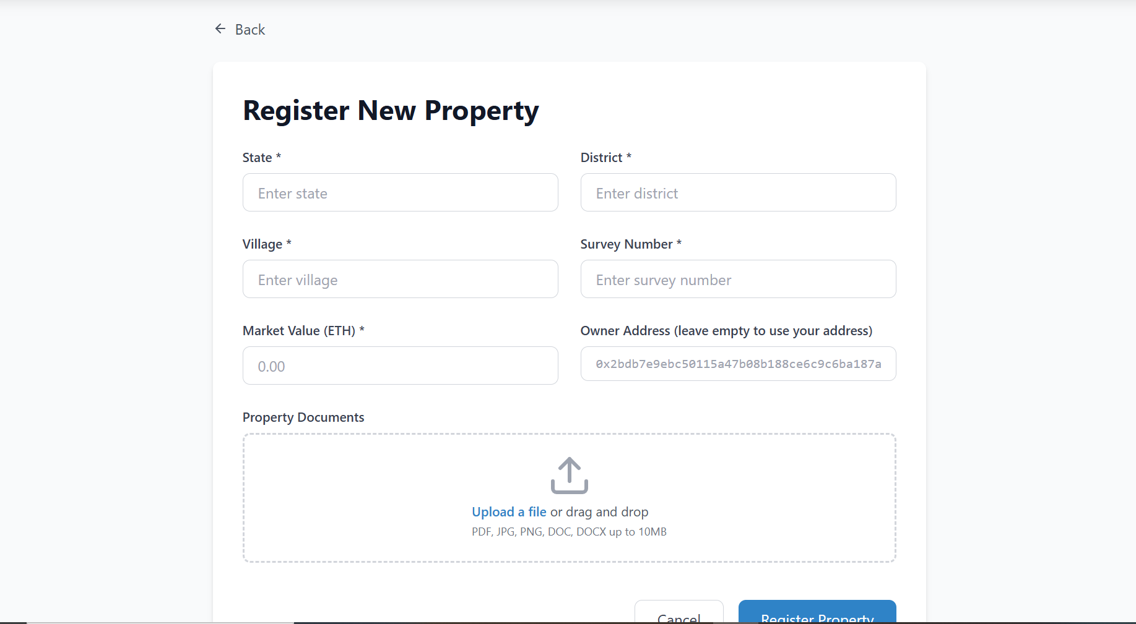
Figure 8: Land Registry Form

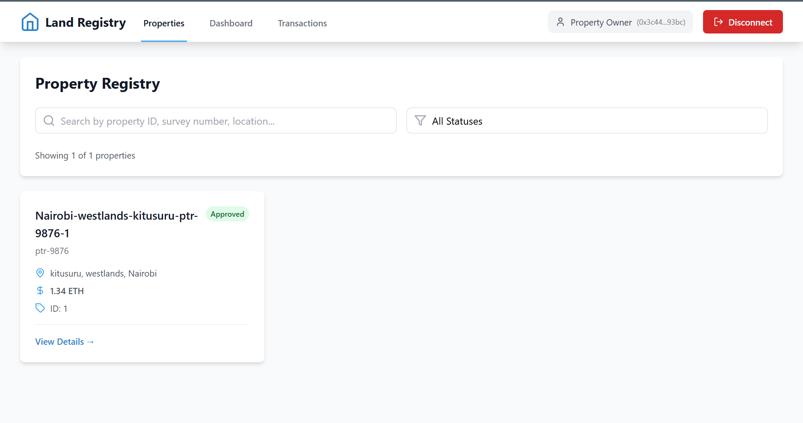
Figure 9: Listed Properties

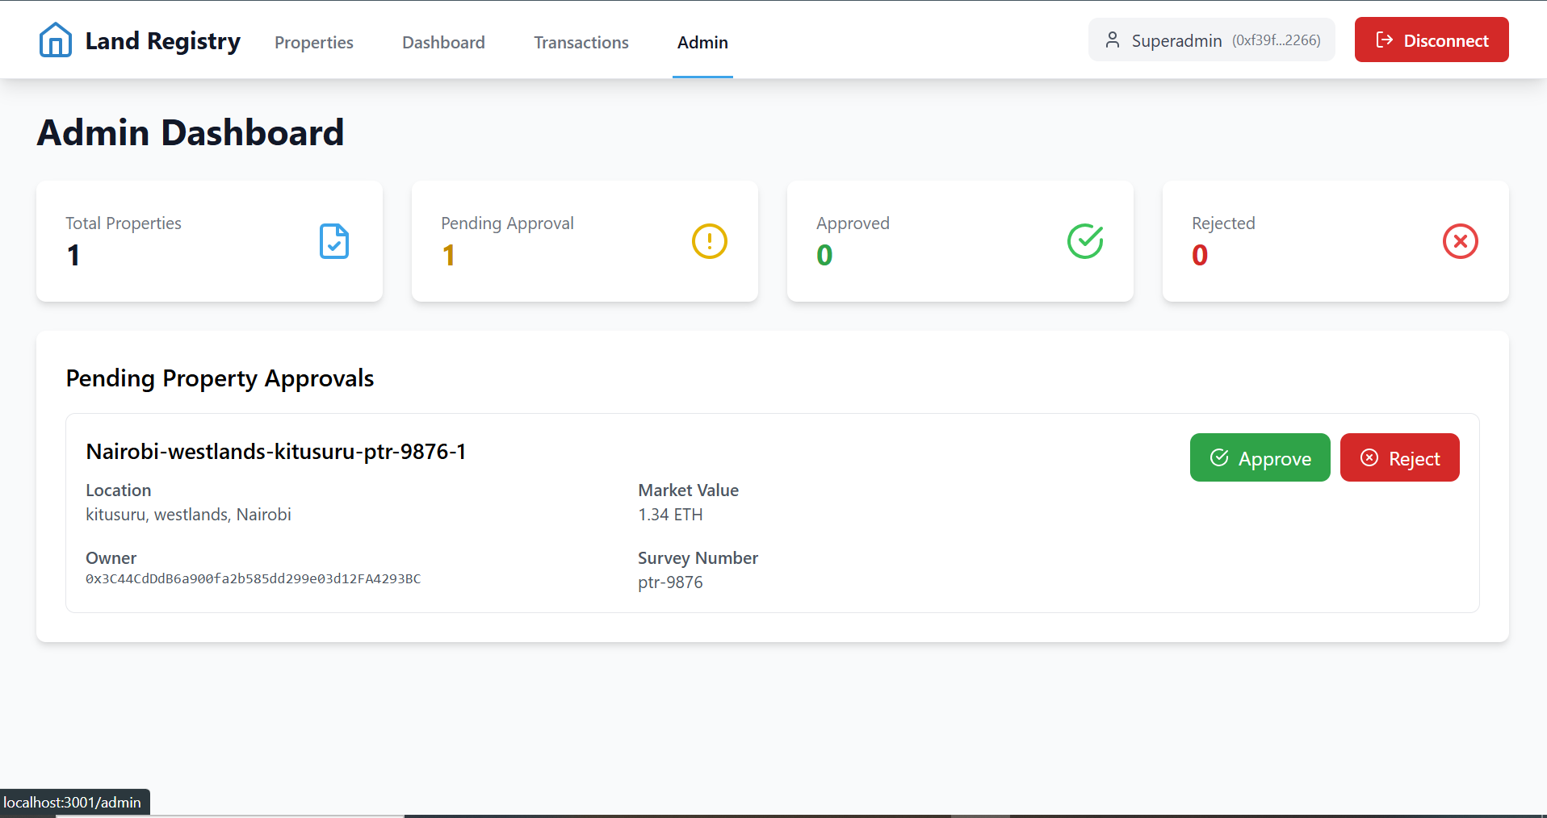
Figure 10:Admin Dashboard

4.4 Testing and Quality Assurance

4.4.1 Testing Strategies
Various types of testing were conducted to ensure the quality and reliability of the system:
- Unit Testing: Verification of individual smart contract functions (e.g., Registration(), buyProperty()), frontend components, and backend logic. This ensured that each isolated part of the system performed as expected.
- Integration Testing: Ensuring seamless operation and data flow between different modules and components, such as the interaction between the frontend DApp and the deployed smart contracts on the Ethereum network, and the integration of user authentication with blockchain transactions.
- User Acceptance Testing (UAT): Gathering feedback from conceptual end-users (e.g., property owners, potential buyers, and superadmins) to validate if the system meets their real-world needs and expectations, assessing usability, workflow, and overall satisfaction.

4.4.2 Results

- All core functionalities (registration, search, transfer) returned correct, immutable results.
- Security tests confirmed that unauthorized roles cannot register land or initiate fake transfers.
- Performance validated with transactions achieving confirmation within a few seconds on Ethereum test networks.
- All UI forms validated for required fields, with feedback for input errors.

4.4.3 Evaluation Metrics
The effectiveness and success of the blockchain-based land registry system were evaluated against specific metrics:
- Transaction Time and Accuracy: Measuring the speed of key operations (e.g., land registration, ownership transfer) and verifying the accuracy of recorded data on the blockchain compared to traditional methods.
- Trust Levels through User Feedback: Assessing the perceived increase in trust and confidence in land transactions and record integrity, captured through user questionnaires and interviews.
- Security and Data Immutability: Verifying the system's resistance to tampering, fraud, and unauthorized access, specifically confirming the immutability of records on the blockchain.
- Admin Efficiency in Moderation: Evaluating how effectively superadmins can manage registrations, process requests, and resolve issues using the provided dashboard, indicating improved administrative oversight.

4.4.4 Issue tracking and Quality Assurance

- Issues and bugs tracked using GitHub Issues.
- Code changes merged only after passing review and CI pipeline tasks.
- Planned for future use of test automation for regression and stress testing.

4.5 Deployment Plan

Development Build: Initial deployment conducted on the Ethereum local testnet (Ganache).
Staging/Production: Ready for migration to Ethereum testnet (e.g., Ropsten/Goerli) for wider user pilot.
Deployment Process:
  - Use of Truffle for smart contract migration.
  - Docker containers set up for backend and frontend.
  - Frontend hosted on Netlify; backend on Heroku (demo phase).

4.6 Go-live Plan

Transition Steps:
  - Backup of test environment and all related data.
  - Final mainnet contract deployment scheduled after successful testnet acceptance.
  - Defined rollback procedure if deployment fails.
Post-deployment Monitoring:
  - Real-time contract event logs reviewed using tools like Etherscan and Ganache logs.
  - Basic monitoring (server uptime, API response, transaction errors).
  - Solicited user feedback through in-app forms.

4.7 Maintenance and Support

Ongoing Maintenance:
  - Regular patching (frontend/backend and contracts) as bugs or vulnerabilities are discovered.
  - Periodic review of smart contract for optimization and compliance with updates to Ethereum network.

Support System:
  - User manual and FAQ provided within the application.
  - Centralized help desk set up via project email/GitHub Discussions.
  - Bug reporting and feature request tracking included in the system.

4.8 Conclusion and Future work

4.8.1 Conclusion

The Land Registry System using Blockchain Technology was successfully designed, implemented, and deployed through well-structured phases. The DApp demonstrated secure and transparent land registration and transfer, immutable transaction records, and significant improvements over traditional registry processes.

4.8.2 Future Work

- Integration of geospatial (GIS) data to provide mapping capabilities.
- Migrating historical land data from legacy systems.
- Enhancement of user authentication (integration with government ID APIs).
- Scalability testing and migration to Ethereum mainnet for live operation.
- Expansion of smart contract functionality (e.g., escrowed payments, dispute resolution modules).

REFERENCES
- Blockchain Council. (2020). Blockchain Technology: A Comprehensive Guide. Blockchain Council Press.
- Buterin, V. (2014). A Next-Generation Smart Contract and Decentralized Application Platform. Ethereum Whitepaper.
- Deshpande, A., & Metri, M. (2018). Blockchain for Land Registry: A Review of Current Initiatives and Future Directions. International Journal of Computer Applications, 179(3), 1-5.
- Lemieux, V. L. (2017). A rich picture of blockchain technology for land administration. Journal of Geodesy, 91(12), 1537-1552.
- Nakamoto, S. (2008). Bitcoin: A Peer-to-Peer Electronic Cash System.
- Pressman, R. S., & Maxim, B. R. (2019). Software Engineering: A Practitioner's Approach (9th ed.). McGraw-Hill Education.
- Swan, M. (2015). Blockchain: Blueprint for a new economy. O'Reilly Media, Inc.
- World Bank. (2019). Blockchain and Distributed Ledger Technologies in Land Administration: A Review. World Bank Group.

